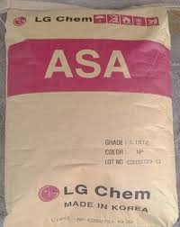

ASA LI913
Наличие на складе:

Наши преимущества

Описание
#описание#
Технические характеристики

Свойства марки
ASA is a copolymer of SAN and acrylic rubber, and it is a highly functional plastic with
excellent weatherability while maintaining most of the advantages of ABS.
Thanks to its excellent retention of physical properties and appearances in outdoor
applications for a long time, it is used as a material for automobile exterior,
construction and furniture finishing sheet, etc.

Доступна фасовка

